Mobile & BYOD printing - Papercut
Web Print is a service to enable printing for laptop, wireless and unauthenticated users without the need to install print drivers. To upload a document for printing, click Submit a Job below.
Note: This wireless printing only available for documents with extension as follows:
PDF,BMP,DIB,GIF,JFIF,JPE,JPEG,JPG.

- If you bring your own device in TOP Campus, you can now print from your own device by following below steps.
- Open your web browser and type https://print.top.edu.au from your mobile device.
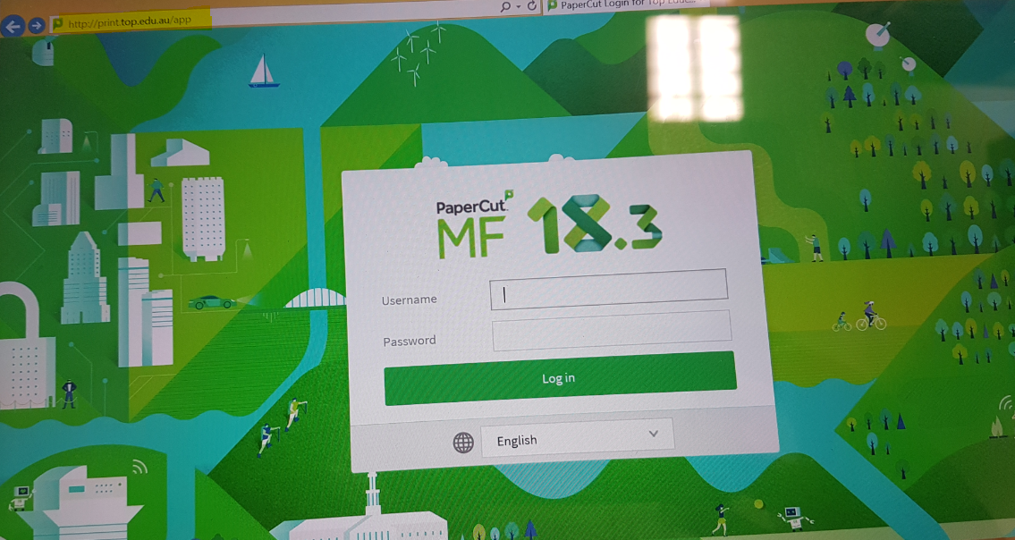
- Enter your Student number and password provided by IT Dept.
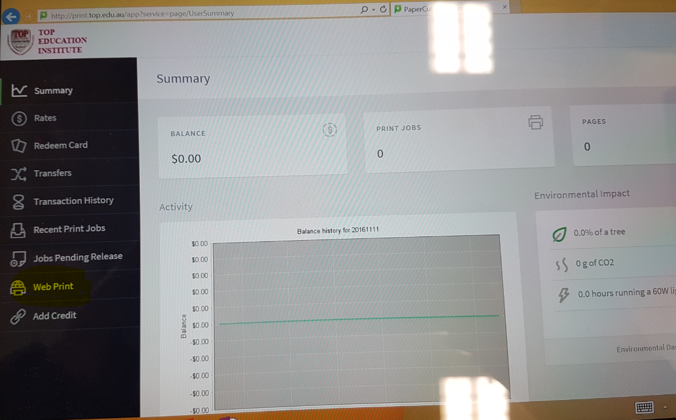
- On the left hand side bar, select or click Web Print.

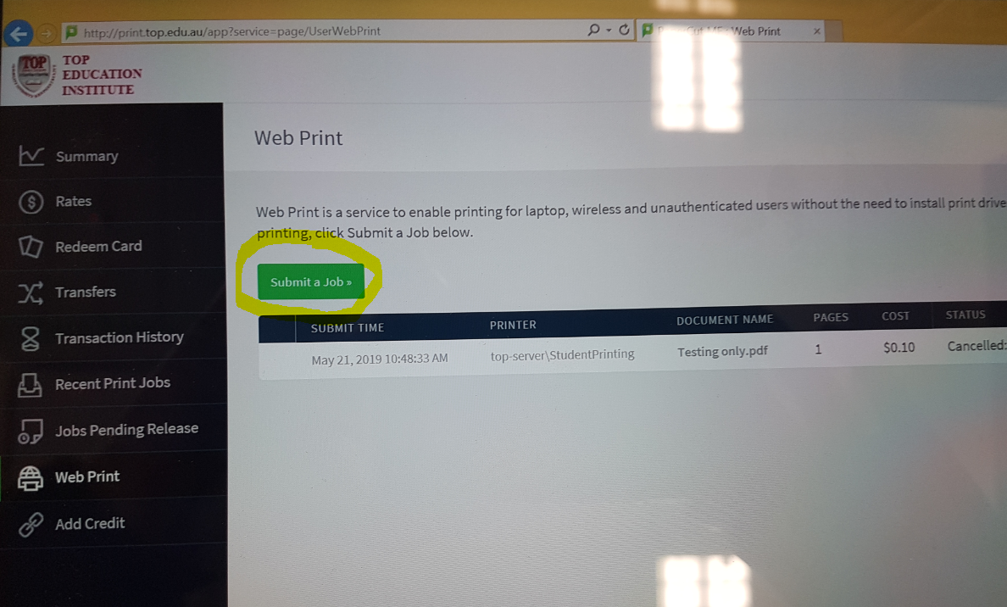

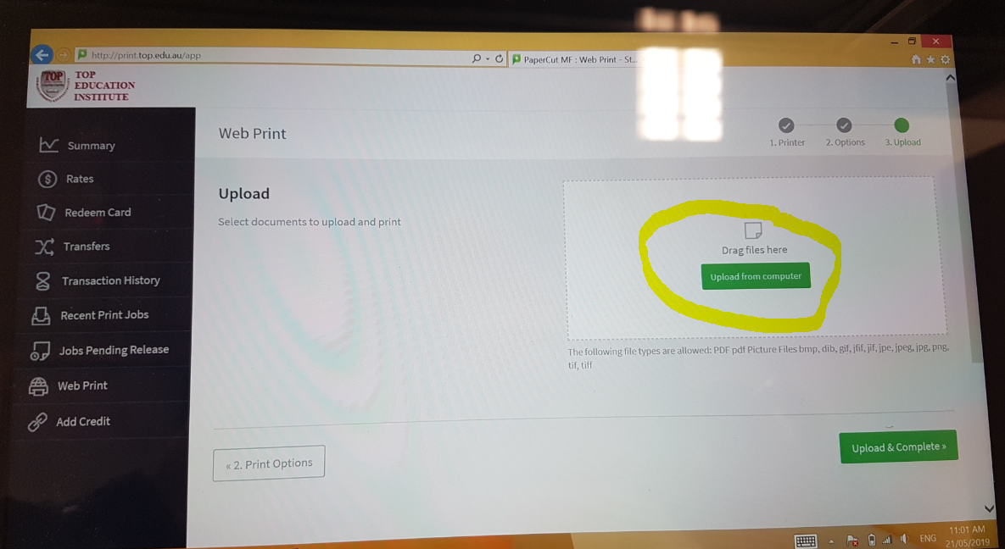
- Then Upload the file you wish to print… Note: Only the following types of files are allowed:
PDF,BMP,DIB,GIF,JFIF,JPE,JPEG,JPG
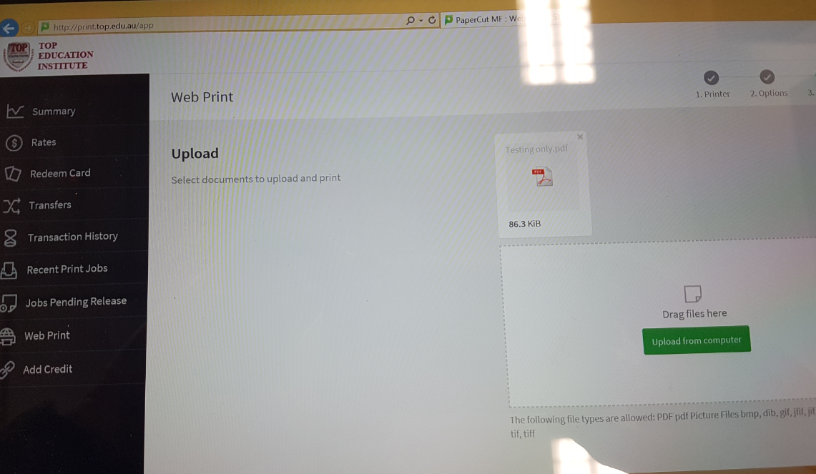
- Once the file has been uploaded, then it will show on upload queue as above.

- Then click the upload and complete once document ready for printing else you can select another documents.
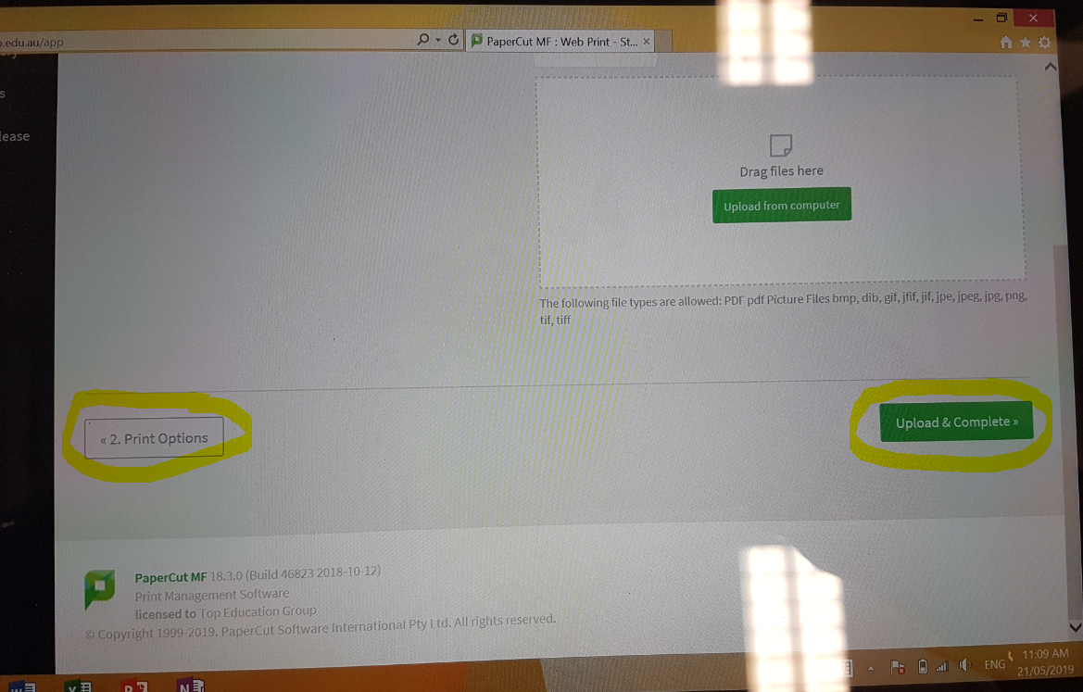

- Once you selected the documents, the press print option and documents will be queued up as highlighted below.

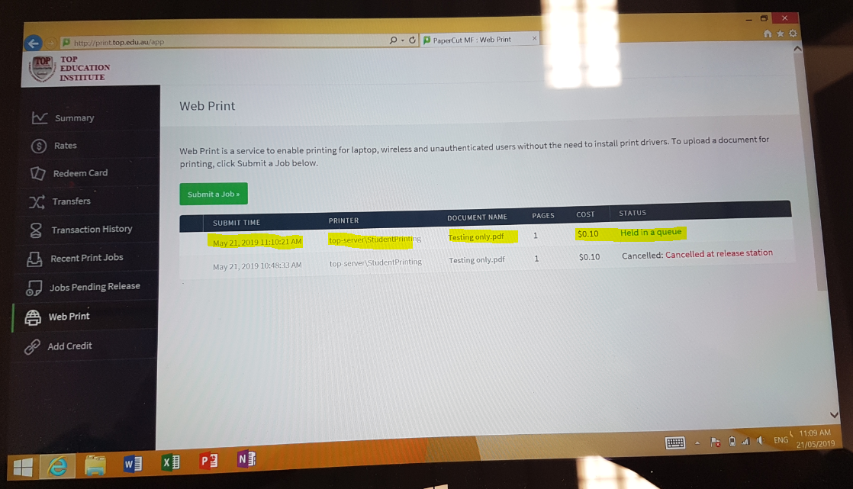

- You can now go to the printer and release the documents by swiping your Student number then press print.

